150:080 Introduction to Information Systems

HMTL In-Class Lab Exercise

Creating and Displaying HTML Pages

Pages written in HTML must be written in plain text (ASCII), which means they contain no platform or program specific information. You may use any editor or word processor (e.g., Notepad, WordPad, Word) capable of saving your document in plain text format. If you choose to use a word processor such as Microsoft Word, be absolutely sure to save your page as text (preferably, DOS text with line breaks). Use the File | Save As… option, NOT the File | Save as HTML… In addition, be sure your HTML page files are always saved with an .html extension.

Since our HTML pages will be relatively small, we will use Notepad, which will automatically save our work in plain text format.

Notepad can be accessed in Windows 95 by selecting:

Start | Programs | Accessories | Notepad

While your initial pages will not require it, you may want to get in the habit of turning on the WordWrap function by selecting Edit | Word Wrap. Word Wrap will make it easier for you to view long lines of text (note that the Word Wrap feature needs to be turned on each time you launch Notepad).

When finished with an HTML page, select File | Save As and enter the name of the file to be saved with an .html extension.

If you wish to view the file, access it via Windows Explorer and double click on the file name. If the file has an .html extension, this should launch the default browser on your computer (Netscape Navigator on campus). Alternatively, launch your browser first, and then use the File | Open command to specify the location of the file you wish to view.

You may move between the browser and Notepad as you edit or troubleshoot your HTML page. Please note the following tips:

- If you close Notepad, and then re-open it to work on a page, the page file may not be visible because of its .html extension. Select the All Files (*.*) option from the drop down list box to view files with all extensions.

- If you change a file, you must save the file in order to view the new changes in the browser. Note that you must save the file every time you wish to view changed pages in the browser.

- If you have saved the file after making changes, and the changes do not appear to have been made in the browser, click on the reload or refresh button to view the latest version of your HTML page.
HTML Hands on Exercise

The purpose of this exercise is to review the creation of a WWW home page using basic HTML tags and Windows Notepad. Follow the steps below to create the content of a web page using Notepad, add simple HTML tags to provide formatting, and enhance the page with additional graphics and links.

Step 1: Create the web page content using Notepad

- Start your computer and use the Windows Notepad program. You can generally find Notepad in the Accessories folder. Notepad is a simple text editor that stores documents in the American Standard Code for Information Interchange (ASCII) format.
- Type the text as shown in Figure 1, substituting your name and other information that pertains to you as appropriate.
- Select Save from the File menu, and save the document as myhome.html on your disk in the A: drive.
- Pull down the File menu a second time and select Exit.
- To see the document, start your WWW browser and select Open file from the File menu. Is the document an HTML document?

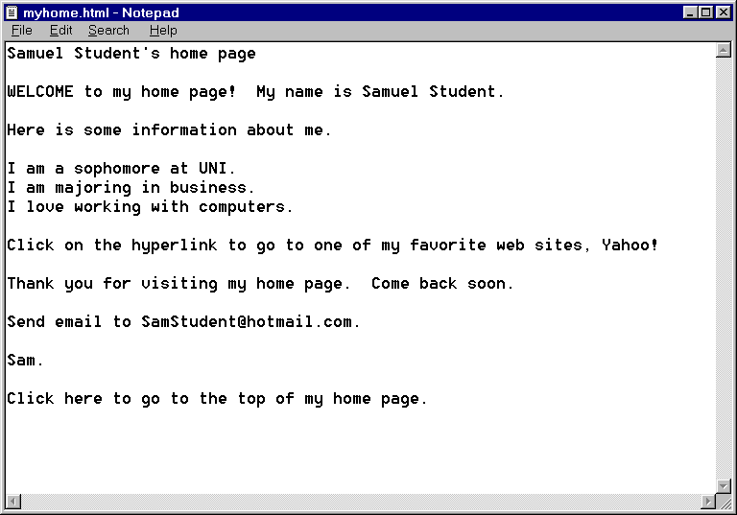

Figure 1: Unformatted Notepad document
Step 2: Add HTML tags

- Return to Notepad and select Open from the File Menu. Be sure you have selected Files of Type: All Files (*.*), not Text Documents. Select myhome.html from the list of files on drive A: and click OK.
- Insert the HTML tags in the document exactly as shown in Figure 2.

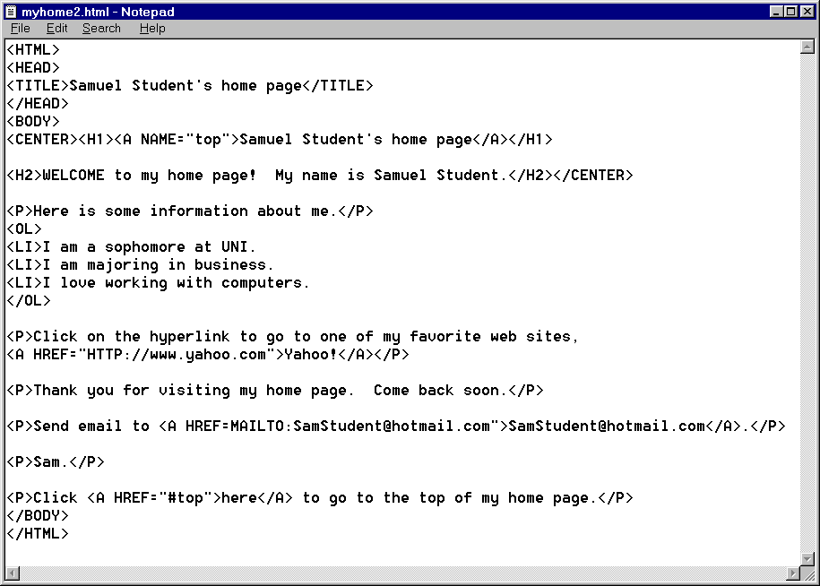

Figure 2: Document with HTML mark-up tags

- Save the document. Pull down the File menu and click Exit to leave Notepad.
- Open the document in your browser using the Open file command from the File menu, and verify that it matches the screen shown in Figure 3 on the following page, with your name and other information inserted in appropriate places.

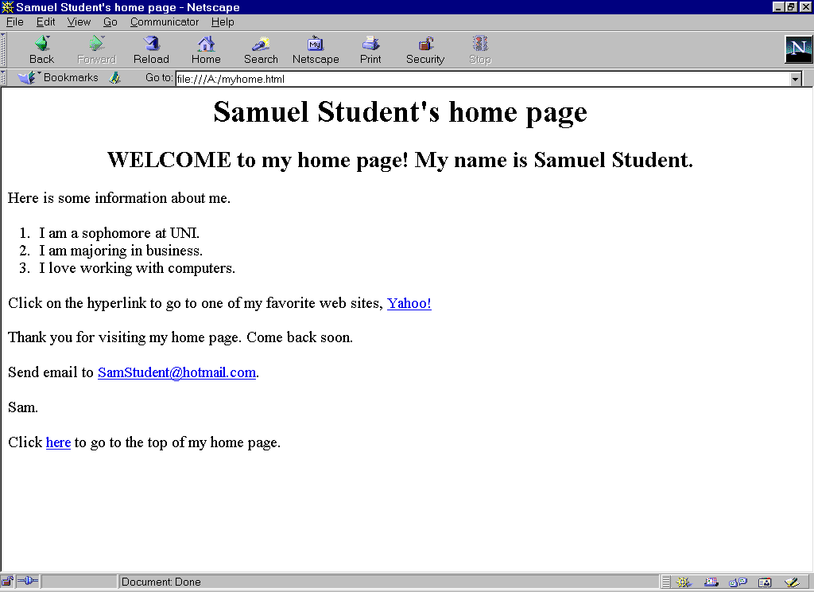

Figure 3: Netscape view of myhome.html

Step 3: Enhance your web page

- Using Notepad, open the file myhome.html
- Insert the horizontal rule tag <HR> below the first heading, Samuel Student’s home page.
- Add an anchor tag to the ordered list to link to one of your favorite sites. For example, add: One of my favorite MP3 sites is http://www.mp3.com.
- Save and close the document.
- Open the document in your browser using the Open File command from the File menu to view your changes.

Step 4: Add graphic images to your web page.

- Before you can insert graphic images in your home page, the GIF image file(s) must be downloaded from the Web or created in a software program. We will download two image files.
- Download the Welcome3D.gif image file. Save this file on the same drive and directory on which you have saved your HTML web page file. Also save the smile.gif image file in the same location on your disk.
- Open myhome.html using Notepad
- Replace the word ‘Welcome’ in the second line of your web page with the HTML image tag <IMG SRC=”Welcome3D.gif”>
- Insert and center a small table (border=5) with the name of your favorite web site, Yahoo!, in the first table cell, and the smile.gif image file in the second table cell
- Save your file. When you view it in your browser, it should look similar to Figure 4.
- Print your web page from the web browser.

