Closing Remarks

The Stars comprise of:

Angela Harris heart@arches.uga.edu

Gonzalo Marturet marturet@arches.uga.edu

Christy Jordan cljordan@arches.uga.edu

Kerrie Harrison kerrie@juno.com

Stephen Davis smdavis@arches.uga.edu

Even though, our project did not fully succeed to help them correct the pricing process, our solutions that we implemented did help to correct the listening bar problem and the old/wrong stickers. Management plans to use our ideas to further correct some of their pricing problems.

The Stars learned the most important lesson in management, which is teamwork. Each of us coming from very different backgrounds were able to come together and work as a team to put together this web page. In the production of this web page, we became Stars.
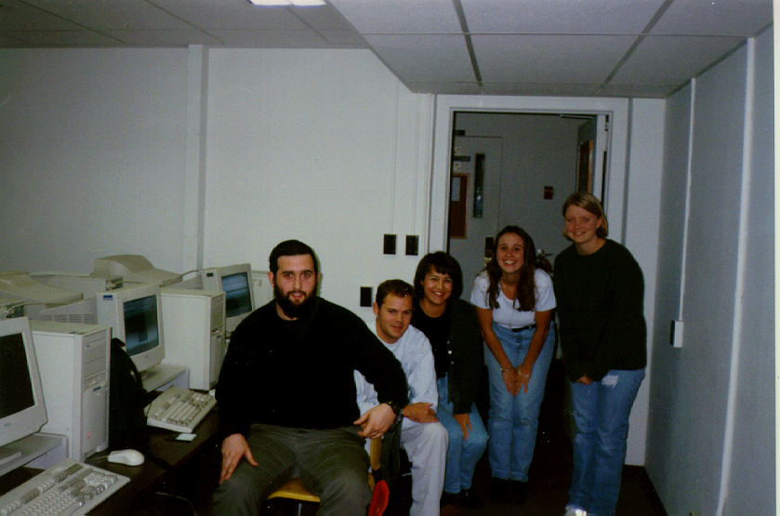

The Stars

