Solutions

Solution 1: The employees were encouraged to scan the CDs from the listening bar to check the price of the CD before repackaging.

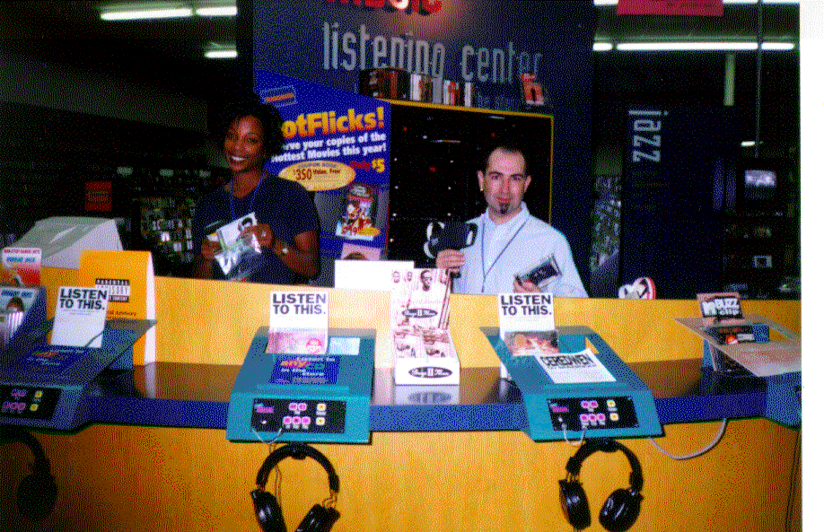

Solution 2: The employees were encouraged to walk the store and look for old stickers on the packages. The CDs were scanned to check the price and if needed the old stickers were replaced with a new updated sticker with the correct price.

