http://blogs.usatoday.com/oped/2007/05/quality_air_ser.html#more

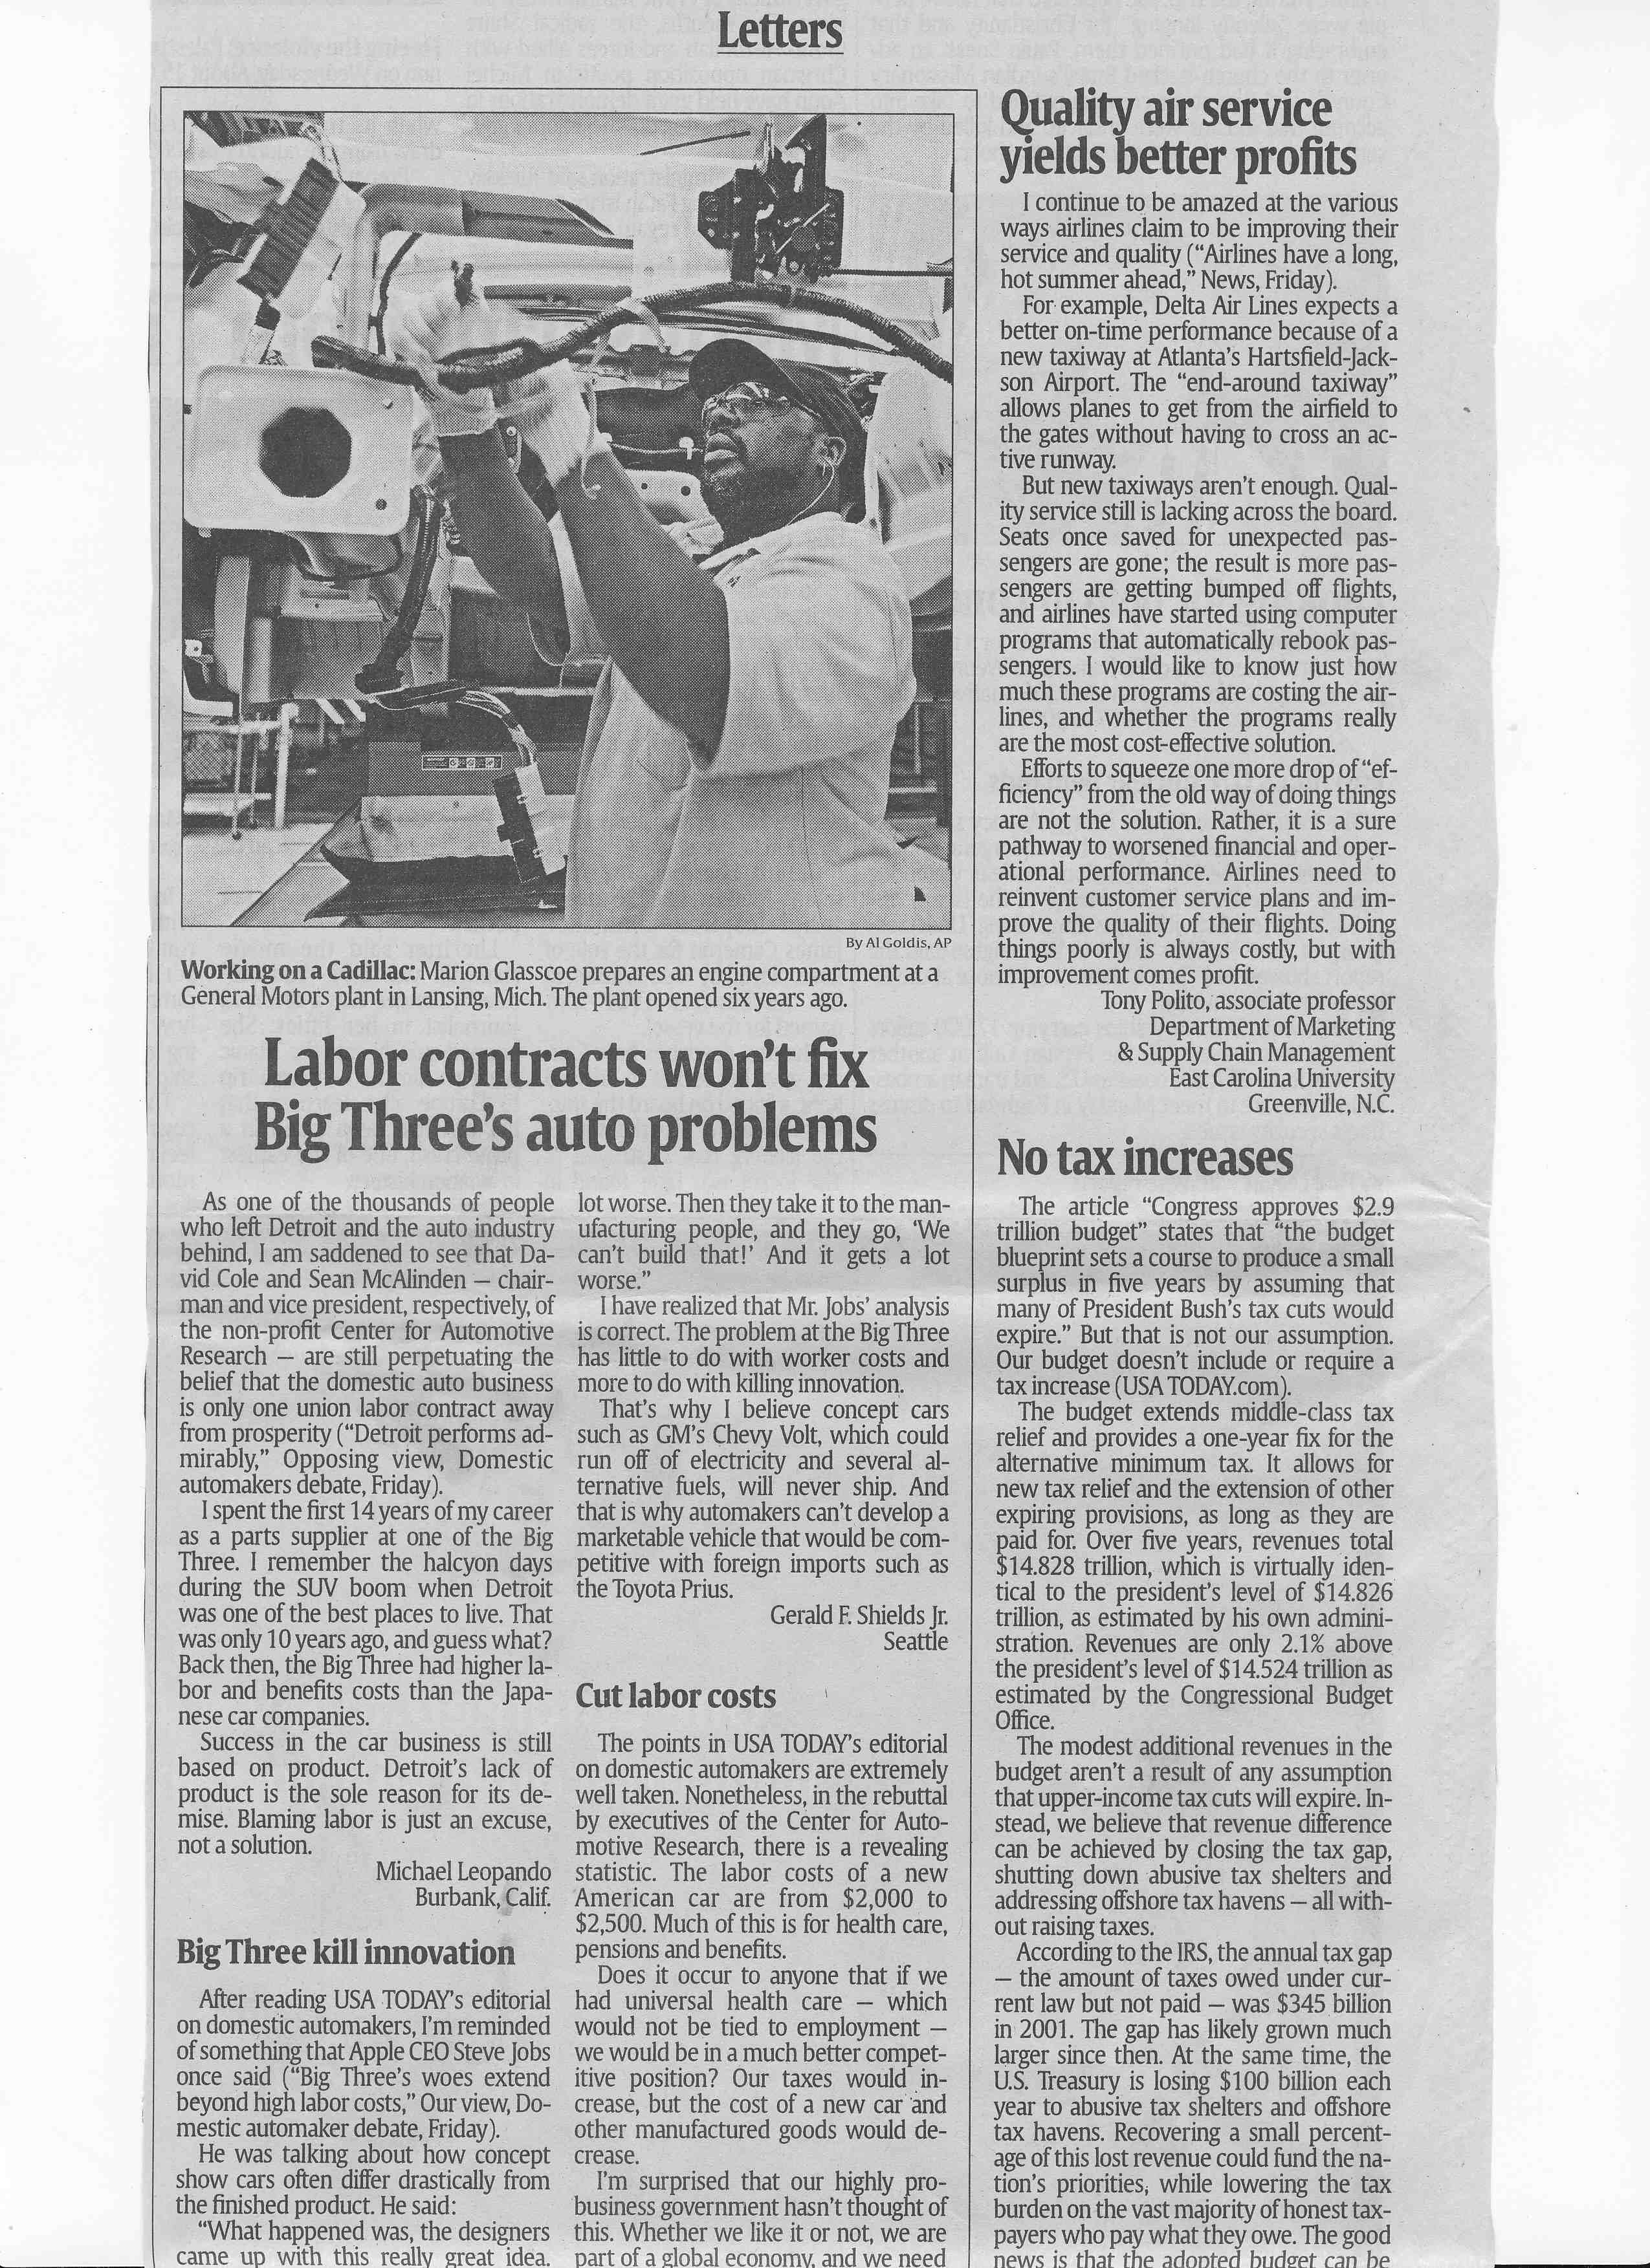

Letter to the editor (as submitted, prior to editing by the editors’ reader)
RE: Airlines have a long, hot summer ahead. 2007. USA Today.

Editors: I continue to be amazed at the various plans airlines have for improving their service and quality. For instance [in "Airlines have a long, hot summer ahead," May 18], Delta expects a better on-time performance from a new taxiway that avoids the delays of planes waiting to taxi over active runways, that "shaves a minute off the [taxi] time."

Of recent, our air transportation system, as a solution, has been consuming any and all of its service/performance buffers. Seats once saved to accommodate unexpected passengers are gone; the result is more passenger bumps than ever before, so much so the airlines have implemented software to 'institutionalize' the bumping process. The cost is surely far more than that of the empty seats. Slack time at gates has been scheduled away as "profitable" flying time; the result is planes that will now taxi so quickly will often idle in wait of gates filled with planes that routinely overrun their departure times. What good comes of the costs for a new taxiway then?

The result of these efforts to eke out yet one more drop of "efficiency" from legacy systems is not a solution, but rather a sure pathway to worsened financial and operational performance in the long run. Those systems must be re-invented, "re-thought from the ground up," to marry to the new marketplace and conditions in which they operate. And, in order to expect profitable operations, the foremost aim of those plans must be the improvement of the quality of the airlines' product and services.

Doing things poorly is always costly; with improvement comes profit.

Tony Polito, Associate Professor, Department of Marketing & Supply Chain Management, East Carolina University, Greenville, North Carolina.

